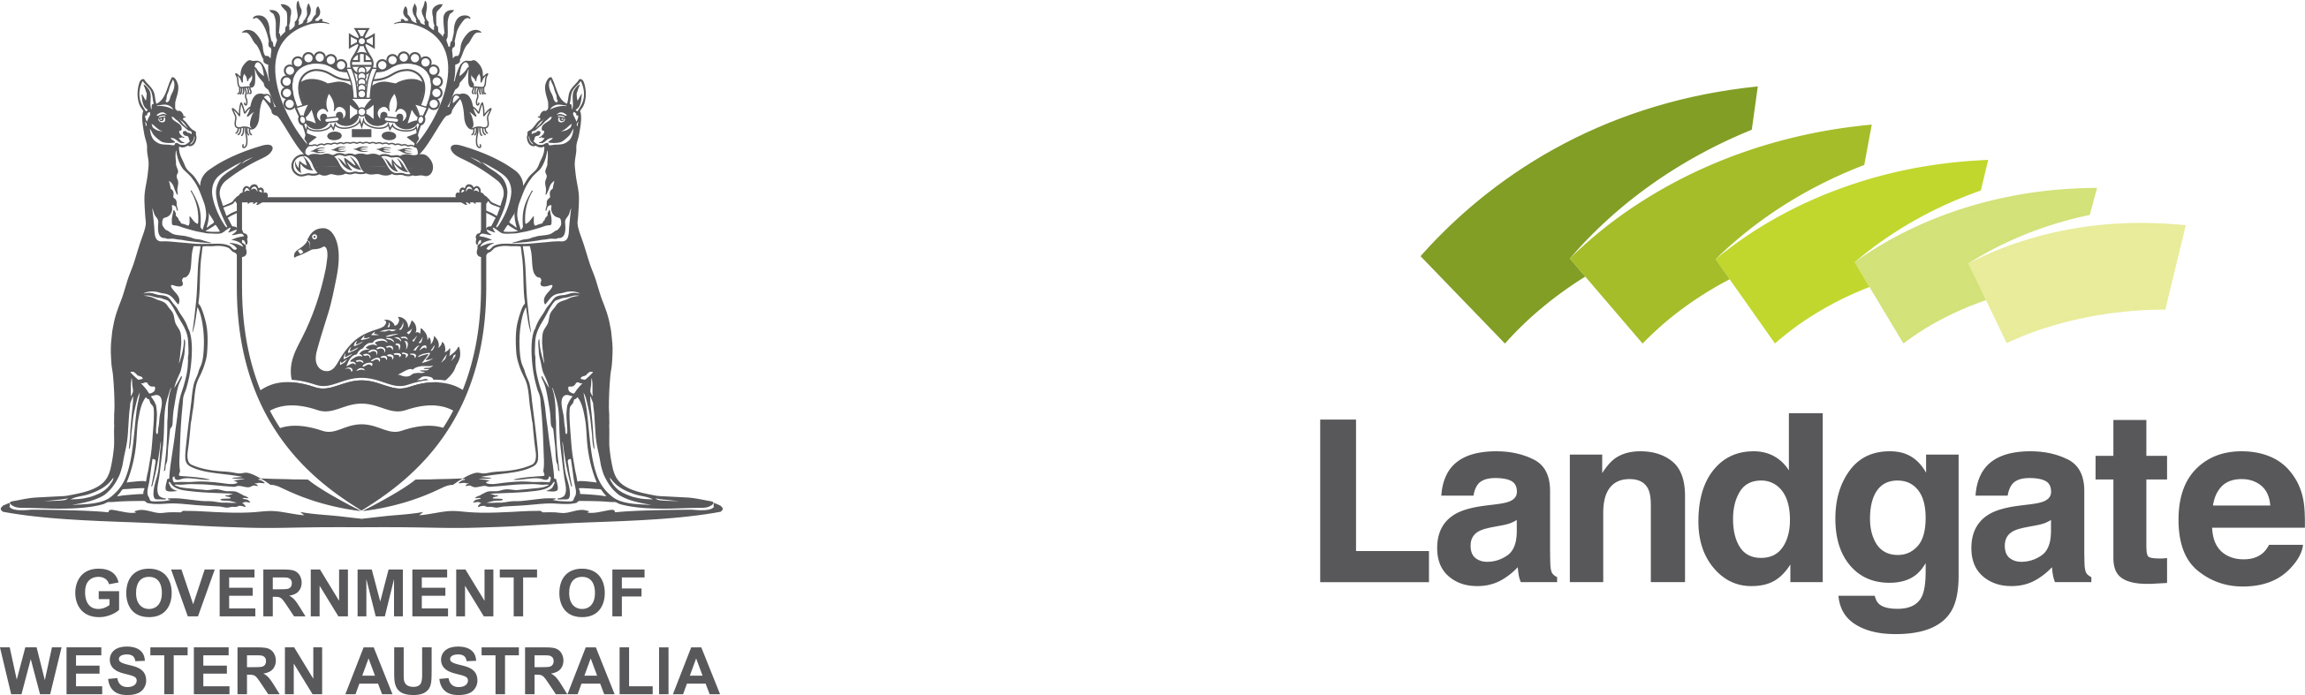

Transcript
1 Midland Square
PO Box 2222, Midland WA 6936
Telephone: +61 (0)8 9273 7373
landgate.wa.gov.au

In the video are:
HackED MCs, HackED hosts, various students from across WA

Transcript
Student 1: The day was really amazing, it helped build our teamwork.
Student 2: Yeah, it's been really enjoyable, like, learned to bond well as a team.
Student 3: Yeah it's been really great, I've really enjoyed managing the team and coming up with different ideas to support our project.
Student 4: It's a really good experience to actually practically, because often in class you can think about these things and, you know, hypothetical... but it's actually interesting to be able to really do it.
Student 5: Well our app is for a more efficient public transport system.
Student 6: We've redone a park in the eastern suburbs for teenagers.
Student 7: So there would be no pollution, no noise... it's basically a healthy way to have fun.
Student 8: Yesterday, today, even right now, someone somewhere in the world are dying because of hatred.
Student 9: Discover the wonder down under.
HackED host 1: It's not just about putting things on a map, it's understanding beyond that, you know, how does it affect everybody that, you know, lives in that area for example.
HackEd MC: Three... two... one... zero!
HackED host 2: But it's my job to announce the winner of the Innovation section, which goes to John Calvin 'J Squad'.
HackED host 3: Team Real' from Morley.
Student 10: Definitely come down to this event, it's a lot of fun, you get to hangout with a lot of people from other schools and you get to express your ideas without any sort of judgement whatsoever.
Student 11: Come along, it's a fantastic day, you'll enjoy yourself, and you will learn new skills that you can take and use in real life.

End of transcript

